SAPIENS Newsletter of Save Albert Park Inc. No. A00409971X Issue 309 June 2023
Could Avalon be the solution to the Grand Prix problem?
Most Save Albert Park members would probably think that the right solution to the Grand Prix problem would be to negotiate cancellation of the race contract. The other option, which SAP has advocated throughout its 29-year existence, is to relocate the event to permanent circuit, with Avalon Airport precinct proposed as an appropriate location. It has now been reported that Motorsport Australia and the Victorian state government have announced plans to build a new permanent motor sport facility at Avalon, within a 150 hectare site owned by the Defence Department.
Motorsport Australia hs been offered $1.6 million to develop a case study for the venue which can be submitted to the government for approval. Apparently the state government will fund the project, with Motor Sport Australia talking control of the operation of the venue as a not-for-profit venture in the interests of the sport. The aim is to create a Silverstone -style facility.
Motorsport Australia has successfully argued that while there are existing motor sport centres such as the Sydney Motorsport Park and Mount Panorama which can be hired, these circuits are not controlled by the sport and are not appropriate for the junior development programs. It was also argued that most sports have control over venues, either under long term leases or deals with governments; for example Tennis Australia’s control of the Australian Open, and Cricket Australia which has a 50-year deal regarding the use of the MCG.
According to the sport’s CEO, Eugene Arocca, the aim is to create a Silverstone-style circuit capable of staging an F1 Grand Prix which is a ‘track for the sport, run by the sport, invested in by the sport’ with the funds generated going back into the sport. It is also proposed that there would also be an ‘industry park’ and a ‘Centre for Excellence’ for the training of drivers and officials in road safety etc.. It is expected that construction of the circuit would commence in late 2026.
Save Albert Park is encouraged by this development as it could possibly lead to the relocation of the Grand Prix event. The justification for relocation is huge. The current use of Albert Park Reserve is wrong in at least five ways, as stated in SAPIENS 308: financially, economically, environmentally, socially and ethically. Despite this, the event has remained in the park because successive state governments seek to curry favour with Melbourne’s powerful hospitality industry and the ‘bogan’ element identified by Jon Faine (The Age 17/4/22).
We can live in hope that we can get a state government which will do the right, sensible thing and either junk the grand prix event or move it to Avalon.
Silverstone Grand Prix circuit, Northhamptonshire UK, which could be the model for a planned motorsport centre at Avalon. The circuit was previously a bomber station (1943-1946) 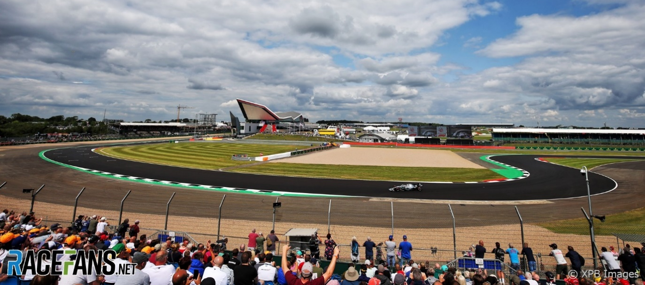
Newcastle’s Supercars ‘blight’
The Newcastle 500 Supercars event was first held in 2017, then in 2018 and 2019. The 2020 – 2022 events were cancelled due to the covid-19 epidemic, and the 2023 event was held last March. The event has been opposed from the outset by community groups, notably by the Newcastle East Residents Group (NERG) which in 2019 produced the book ‘Wrong Track’, written by Christine Everingham and Therese Doyle.
Newcastle’s Supercars event operates under a three-way agreement between the NSW government, Supercars Australia and the City of Newcastle. A five-year extension of the race contract is now under consideration.
Christine Everingham had a letter published in the Sydney Morning Herald on June 8 regarding the use of public space for ticketed events and a relevant extract is shown below:
Hosting the Supercars ‘Newcastle 500’ event requires handing over the Newcastle East peninsular to a private corporation for nine weeks every year. Public roads and parks are closed to set up barricades and infrastructure for the three-day event.
More than 2000 people live inside the barricaded area and must take out accreditation from the promoter to access their own homes. Local businesses suffer weeks of traffic disruption, loss of parking access and amenity. The usual clientele dwindles and many people leave town to escape the noise and disruption. Most local businesses lose thousands of dollars. The local surf club closes three weeks early due to restricted access to the beach.
Unverifiable attendance figures are given to Destination NSW (which underwrites the event) by the Supercars promoter to justify the local disruption and losses and the public money spent to host the event and provide essential services. Costs are ‘commercial in confidence’.
There is no assessment of the losses incurred by the city businesses despite a hefty chunk of the profits going to outside caterers. The government needs to ask ‘who really benefits from each major event they host and at what cost?.’
Save Albert Park extends its support and sympathy to Christine, her colleagues, and to the residents of Newcastle.
This photo, (reproduced from the book ‘Wrong Track’) shows how the circuit fencing is erected directly in front of some houses.

Dubious Grand Prix economics
A media release headed ‘Grand Prix revs up job opportunities for Victorians’ issued on March 22, 2023 by the state Minister for Major Events, Steve Dimopoulos, stated that an economic study by Ernst and Young had estimated that the 2022 Grand Prix had increased Victoria’s gross state product by $171 million. This stirred SAP’s interest, but the report was not made available to the public. It required SAP’s use of freedom-of -information processes, including an appeal to the Office of the Information Commissioner, to obtain a copy.
EY’s study, an ‘economic impact assessment’ (which considered revenue generated by the event, not costs) proved to be more of a promotional document designed to justify the staging of the event, rather than a serious economic assessment. Four of its 14 pages were used just to display the same photo of packed pit straight grandstands.
The opening page, headed ’Disclaimer,’ was devoted to explaining the study’s many limitations. We quote one paragraph:
EY has prepared the report for the benefit of the client and has considered only the interests of the client. EY has not been engaged to act, and has not acted as advisor to any other party. Accordingly EY makes no representations as to the appropriateness, accuracy or completeness for any other party’s purposes. No reliance may be placed upon the report by any party (“Third Parties”) other than the client.
The key finding of the report, ie the ‘total economic impact’, as measured by an increase in gross state product, was found to be $171 million, comprising the sum of direct expenditure by grand prix visitors ($92 million), plus the assumed expenditure by Victorian residents that remain in the state due to Victoria hosting the Grand Prix instead of another state ($26 million), plus added value determined by multiplier factors. EY stated that,in their economic analysis, they used an ‘input-output’ model which has certain limitations which should.be recognized.
To summarise, EY’s report is a curious document as its purpose is unclear. Perhaps it was commissioned for internal government use to promote major events against competing interests, eg,. funding of social housing. EY was not totally honest in choosing to use the out-dated input-output analysis model in order to report the highest result.

The methodology makes all the difference
The Grand Prix event has been subjected to six economic studies on Grand Prix events, in 1996, 2000, 2005, 2011, 2014 and 2022, commissioned by the state government. Significantly, they have all been economic impact studies, which always deliver a positive result, but do not assess the overall economic benefit or loss. The reason for this is obvious: while the event is staged in a temporary Albert Park circuit it can never deliver a positive financial result or an economic benefit.
Economic impact studies always deliver a positive result as they determine revenue generated in terms of the increase in ‘gross domestic product’ (GDP), which is defined as the monetary measure of the market value of all the goods and services produced in a specific period. Victoria’s 2022 GDP was $515 billion, increasing by $41 billion from 2021. The contribution to the state’s GDP by the 2022 Grand Prix, $171 million, was an insignificant 0.03%.
Following three years of lobbying by SAP, in 2007 the Auditor-General’s Office released a full cost-benefit analysis of the 2005 Grand Prix. This study reported an operating loss of $6.7 million, and an increase in GDP of $62.4 million. The 2005 economic impact study, commissioned by the state government, which used the out-dated input-output methodology, reported a GDP increase of $174.8 million.
Cost-benefit analyses by Economists at Large on the 2011 and 2012 events, commissioned by SAP, reported net economic losses on these events of $51.7 million and $60.5 million respectively.

Looking back
Save Albert Park’s campaign in the mid 1990’ s included the publication of a newspaper, the ‘Albert Park Guardian’. The Number 4, February-March 1996 issue reported the growing number of accidents on the park roads following their re-development into a car racing circuit. Over the period May 22,1995 to January 25, 2001, SAP recorded 175 accidents, mainly single vehicles out of control at corners (eg. at ‘Turn 15’)’ and smashing through the fencing.
The item on Hitler’s apparent love of Grand Prix racing was also featured in the Number 4 issue.
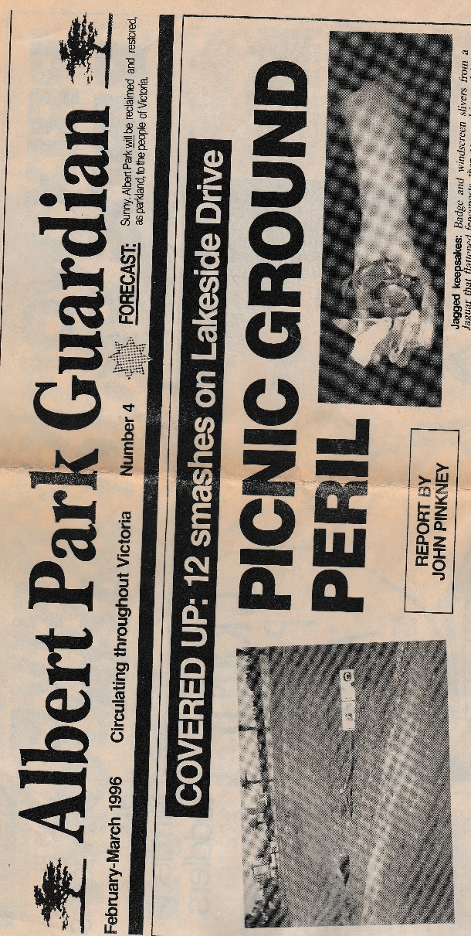

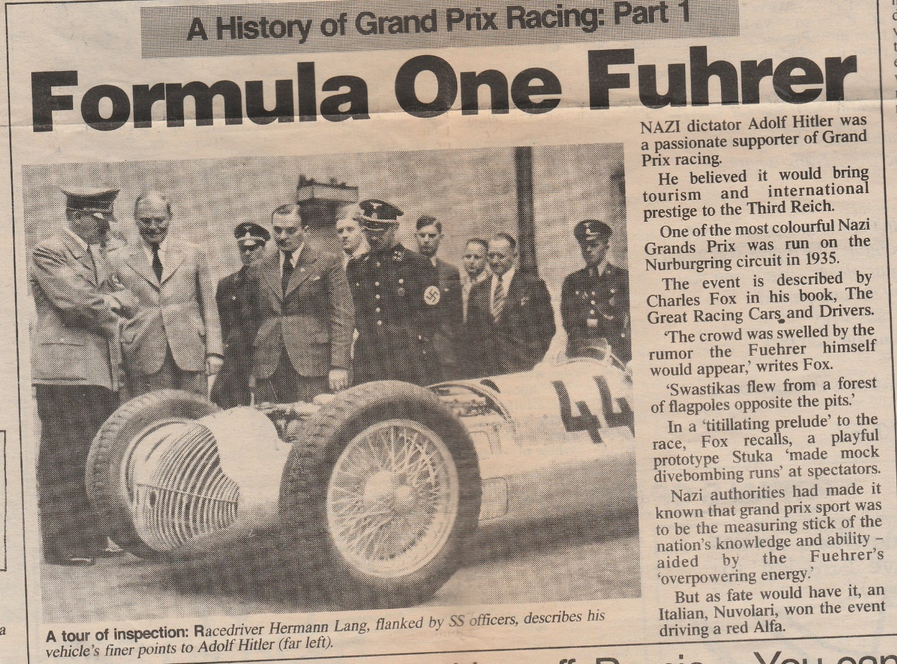
Save Albert Park Inc. No. A0040971X
Media enquiries: Peter Logan, tel. 0412 697 074; email peterandjoanlogan@hotmail.com
Membership/accounts: Greg Byrne, tel. 9645 1301; email greg-byrne@bigpond.com
SAP Newsletter/campaign: Peter Goad, tel. 9699 7932; email pwgoad@outlook.com
Post: PO Box 1300, South Melbourne BC 32

