SAPIENS Newsletter of Save Albert Park Inc. No. A00409971X Issue 308 April 2023
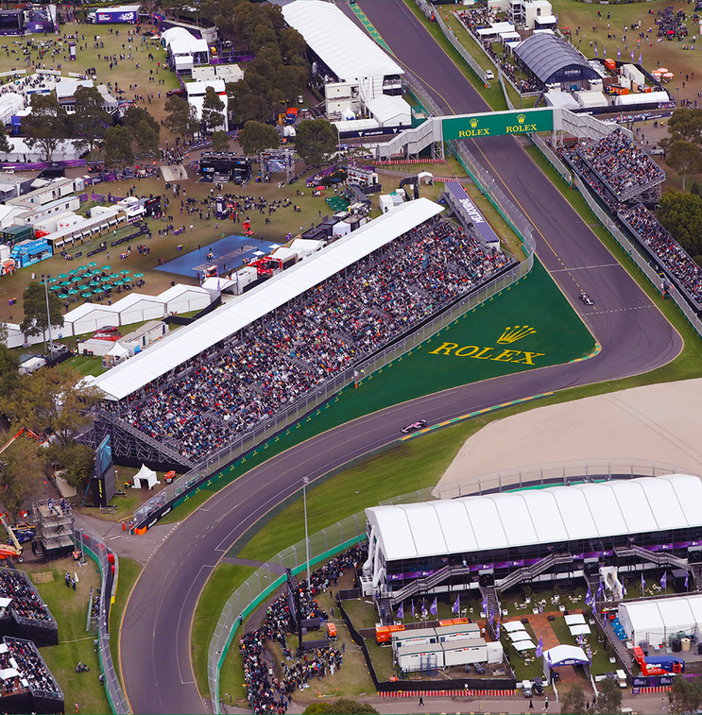
A beautiful public park transformed: Turns 1 and 2 of the 2023 ‘Formula 1 Rolex Australian F1 Grand Prix’ circuit
This photograph illustrates the effect the Grand Prix event has on the sports clubs based in the park. At the right is the ‘pit straight’ section of Aughtie Drive and to the left, covered with buildings and marquees, are playing fields 17 and 20.
The 4-5 month Grand Prix occupation of Albert Park Reserve means that the sports clubs are forced off their grounds and pavilions for up to three months to allow for set-up and take-down of race infrastructure and repair of damage.
At the lower right in the photograph is Oval 21 which is used as the site for the huge corporate ‘Chicane Pavilion’, and a gravel trap at the end of pit straight. Oval 21 is so damaged by the Grand Prix construction works that it cannot be used for normal sports activities throughout the year. At the top right, above the overpass and close to pit straight is a collection of eateries and toilets built over field 18.
The clubs are financially compensated to some extent but this does not offset the loss of the their grounds.
For more information call Hugo Armstrong, President, Albert Park Sports Clubs Association, 0409 311 928

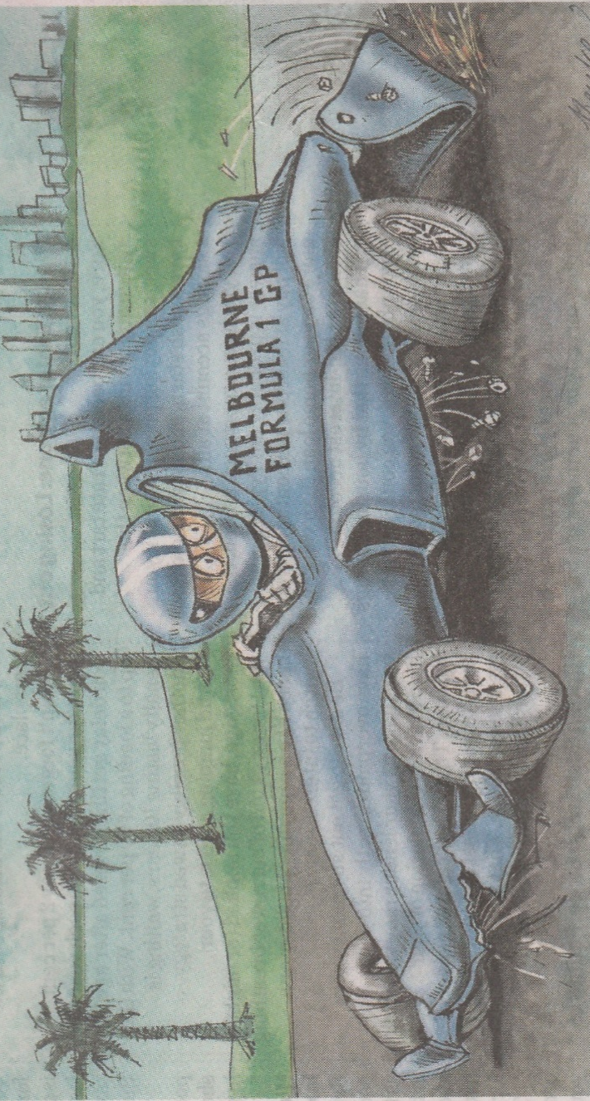 This cartoon by Joe Benke was used in the Sunday Age of April 9 to illustrate Jon Faine’s article, ‘Three strikes on safety’, which concerned the safety issues with F1 Grand Prix racing (see Page 4). Below we have set out five ways that that the F1 Grand prix in Albert Park Reserve is wrong. We can now add a sixth way: it’s a safety risk.
Financially wrong Over a billion dollars of public funds has been lost on staging the event to date (with a further billion likely 2023-2037), feeding profit for the US owners of Formula 1 racing and the local firms involved in building the temporary circuit in the park and staging the event, but producing no tangible benefits for the Victorian public.
Economically wrong - There is no evidence of a net economic benefit to the state in terms of the spending by out-of-state race fans, or from ‘global exposure’. No business case or cost-benefit analysis has been commissioned by the state government to justify continuation of the event. ‘Economic impact’ estimates, which do not consider costs and are entirely misleading, are used to promote the event.
Environmentally wrong The park is subjected to 4-5 months of set-up and take down of a temporary circuit which destroys the peaceful ambience of the park. The use of a temporary circuit generates significant emissions from transport of the circuit infrastructure involving 66,000 km of truck trips carrying 40,000 tonnes of race rear from an Altona depot to Albert Park and back again.
Socially wrong Albert Park Reserve is a major venue for community sport but the Grand Prix event takes precedence and sports clubs based in the park lose their grounds for up to three months. The park has been re-designed essentially for car racing, not for the enjoyment of the public, and further development in accordance with the park Master Plan is restricted’ or prevented altogether (eg., tree planting is restricted). The high cost of the Grand Prix ($78 million was lost on the 2022 event) diverts public funds away from socially beneficial projects (eg public housing).
Ethically wrong The Grand Prix event is promoted by using misleading attendance claims. An ‘estimated attendance’ of ‘more than 419,000’ was claimed for the 2022 event, but the ticket sales revenue ($56.03 million) and other evidence, indicates only around 192,000 tickets were sold. With the aid of the US-based owners of F1, the event is high-pressure promoted as spectator entertainment, and it provides its own gambling system.

The 2023 Australian F1 Grand Prix …..
‘the show deliberately placed above the sport’
The much trumpeted Australian F1 Grand Prix event did not receive much positive comment, apart from references to the claimed ‘record’ attendance of 444,631. (SAP’s calculations put the real patronage of the event by individual fans at around 205,000.) The Age of April 3 ran an article headed ‘A crazy race’ by Chip Le Grand, which described the event as ‘the most chaotic race run at the Albert Park circuit’.
The grandprix.com website of April 3, published a review of the 2023 Australian Grand Prix headed ‘F1 slammed as animator of chaos in Australian GP’. Extracts from this review are quoted below.
F1 is facing near unanimous backlash after “the show” overtook the sport at the Australian GP.
World champion and Melbourne winner Max Verstappen warned earlier in the weekend that he won’t be here long if F1 pushes ahead with initiatives like the proposed sprint format for qualifying.
…. Formula 1 is facing widespread negative feedback after multiple red flag periods and grid re-starts - one of which with just two laps to go – turned the excitement into a farce.
….the show turned into carnage. The question inevitably arises now as to whether the show was deliberately placed above the sport.
There appears to be a feeling that the Albert Park race reflects the policy of the owners of the Formula 1 race series, the US company Liberty Media, which sees Formula 1 racing just as another money-maker. This of course adds to the validity of SAP’s position that the staging of one of Liberty Media ‘s races in Albert Park Reserve is entirely inappropriate.
Great entertainment for the fans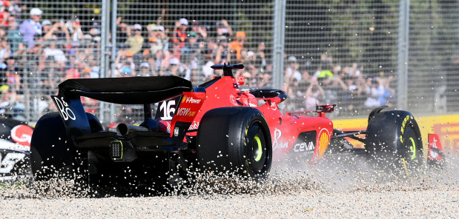

‘…. it was sheer luck that nobody was killed or maimed…’
The main ‘Opinion’ article in the Sunday Age of April 9, was Jon Faine’s ‘Three Strikes on Safety’ illustrated by the Joe Benke’s cartoon shown on page 2. The article’s central point was that a temporary grand prix circuit is inherently less safe than a purpose-built permanent circuit.
The first paragraph read:
‘Contrary to the slick spin from the promoters, the Formula 1 Australian Grand Prix last weekend was a mess. It was sheer luck that nobody was killed or maimed, as has happened before at the second-rate temporary circuit built each year around Albert Park Lake.
It is not the first or second time hat safety protocols have failed at the grand prix. It is the third time in 20 years. No amount of corporate schmooze can cover the persistent failure to run the race in strict compliance with international rules designed to protect spectators from the inherent risks of motor sport.’
The article went on to describe an incident at the 2017 grand prix when spectators entered the track while cars were still circulating, and the accident during the 2001 event when the track marshal Graham Beveridge was killed by a wheel from a crashed car.
Among the final statements in Jon Faine’s article was this : ‘ …. inarguably, the massive risks in motor sport are minimised when the event is staged at a purpose-built racetrack , not one that is assembled and dismantled each year.’
At each grand prix the AGPC issues a warning that ‘motor racing is dangerous and accidents can happen’, together with a statement that says, in effect, that if you and any family members are injured or killed when attending the event, the AGPC and any associate entities cannot be held responsible. In other words, you attend the event at your own risk.

‘Avalon chosen for proposed new home of motorsport’
This was the headline of a media release issued on April 15 by the office of the Victorian Premier. The media release stated: ‘Motor sport in Victoria is on track to shift into a new era, with the Avalon Airport precinct named as the site of the state’s proposed Home of Motorsport – backed by the Victorian Labor Government.’
The proposal ‘…… is listed as a priority in the recently announced 2022-32 Victorian Motorsport Infrastructure and Participation Strategy, which will help to sustain the high number of motorsport events held in Victoria from grass roots to elite level.’
This is interesting and a bit promising for SAP which has for many years has advocated the relocation of the grand prix to Avalon. The photo below shows the Avalon Airport and the industrial area. There could be an opportunity to create a lake to enhance the proposed motorsport circuit!
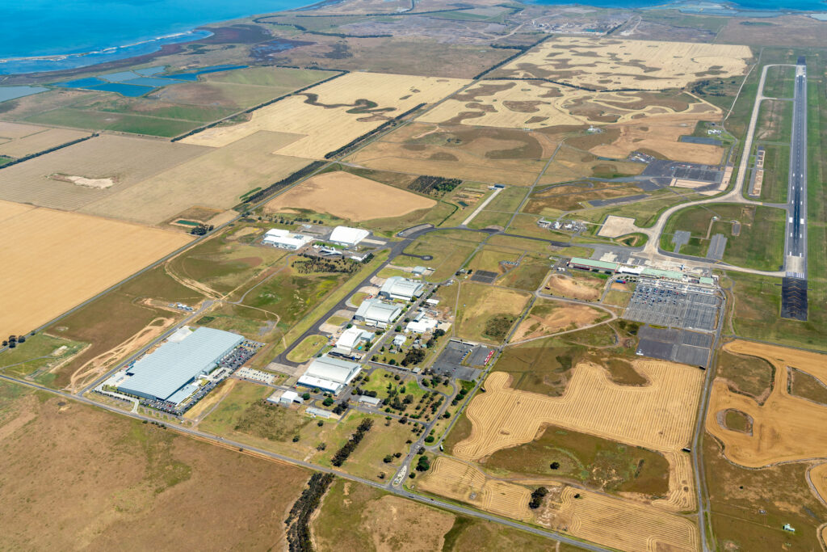
Save Albert Park Inc.
No. A0040971X
Contacts:
Media enquiries
Tel. 0412 697 074
Newsletter
Tel. 9699 7932

