SAPIENS Newsletter of Save Albert Park Inc. No. A00409971X
Issue 307 February 2023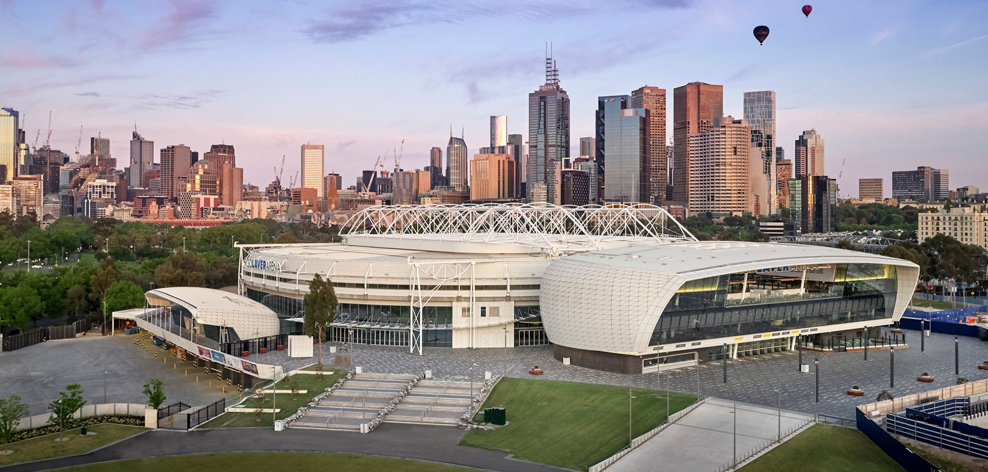
The Rod Laver Arena: a spectacular venue for the Australian Tennis Open, built to achieve a world class level of sustainability. (Photo ref.: coxarchitecture.com.au/rod-laver-arena)
The Grand Prix and the Tennis Open: what a contrast!
The grand prix and the Australian Tennis Open are both major spectator entertainment events but are poles apart in terms of economic and promotional value to the state, concern for the environment and the general well-being of the attendees.
The Tennis Open is owned and organized by Tennis Australia (TA), which is a not-for-profit company based in Melbourne and owned by tennis associations in the Australian states and territories. TA mounts various tennis tournaments around the country and receives government grants but its financial reports show that these are a minor source of income. It appears that TA could survive without government aid.
The Australian Tennis Open is one of four high profile ‘Grand Slam’ tournaments around the world, with the others in Paris, London and New York. It is staged annually at the state government-owned Melbourne Tennis Centre. The centre operates, apparently profitably, the year round providing a venue for various events and purposes, not only tennis. The Tennis Centre has been recently re-developed to achieve a world class sustainability rating, using energy efficient lighting, air conditioning and water recycling systems and installing 370 solar panels on rooftops. The comfort of patrons has also been given a high priority. A record 902,312 attendance has been claimed for the 2023 event, with many being high spenders from outside the state.
The Melbourne Grand Prix event is one of 23 Formula 1 races in an annual series owned and operated for private profit by the US company, Liberty Media. To stage the race event, the Victorian government pays this company an annual hosting fee of over $50 million.
The event is staged in a temporary circuit in public park which has to be built every year at a cost (in 2022) of $43 million (ie over half the overall financial loss). The event, by its nature, is a fossil fuel polluter, and the construction, dismantling and transport of thousands of tonnes of circuit infrastructure generates significant additional greenhouse gas emissions.
Formula 1 racing glorifies very fast car driving (the cause of much public anguish) and a very high level of sound with an accompanying risk to hearing, plus some risk to the general safety of spectators. In contrast, watching tennis at the Australian Open is safe, comfortable and both entertaining and instructive as almost anyone can play the game and relate to the match tactics. In order to promote the Grand Prix event, attendance numbers are inflated by the addition of free tickets issued and attendances by staff. Tennis Australia does not need to stoop to this level.
This is the ‘Jones’ grandstand on January 26 (two months ahead of the grand pix event) being built at the north end of pit straight, partly over the playground and picnic area on the right.
15 more years of grand prix financial folly?
The 2022 grand prix was staged at a loss of $78.12 million in public funds, and with the event contract extended to 2037, and annual cost rises likely to be at least 5%, we are faced with 15 years of increasing losses. A cumulative loss of around $1.8 billion is to be expected. Add to that the billion plus already sent down the drain during the past 27 years. the total loss on the event will be close to three billion. That’s a lot of taxpayers’ cash, and it adds to the state’ current net debt of around $100 billion. You would think that a responsible government would have justified the race contract extension with a comprehensive business case.
But no, there has been no business case undertaken and the findings of the Auditor-General’s cost benefit analysis of the 2005 event (instigated by SAP) continue to be ignored. All we have seen to justify the likely $1.8 billion bill are statements from the Minister for Sport and Major Events, Steve Dimopoulos, that “a recent economic impact assessment of the 2022 Grand Prix conducted by Ernst and Young found that the race boosted Victoria’s gross domestic product by $171 million”, and that the event will “boost business and jobs across Victoria while showcasing the state to millions of spectators (TV viewers?) right across the globe.” We have requested a copy of the Ernst and Young assessment but we have been refused access.
A boost to gross domestic product (GDP) is not a measure of economic benefit. As was stated by the right wing Institute of Public Affairs many years ago, staging the grand prix is akin to painting the rocks in the Yarra red: it boosts the paint industry, creates jobs and increases the state’s GDP, but does not increase the overall welfare of Victorian citizens.
More about the Tennis Open
The report on the Tennis Open in The Age on January 31 contained some interesting comments, The ‘record’ attendance figure of just over 900,000 can be believed, assuming that this figure included some repeat attendances by the same people and that a number of free tickets were issued. Certainly, the attendance number was not inflated by adding in the event staff and competitors as happens with the grand prix event.
The attendance at the Melbourne’s 2023 Tennis Open was stated to be the best of the four ‘Grand Slam’ events, and the organizers expect to make a ‘small profit’. As expected the event boosted the takings of the city’s hotels but it appears that they were not anything like full. The Marriott Group of hotels reported an occupancy of 84%. This is a significant as it suggests that claims that the grand prix fills the hotels could be just a myth. In contrast, restaurants reported ‘a great couple of weeks.

‘……another body blow to community sport in Albert Park Reserve …’
On the following page we have reproduced a media release issued by the Albert Park Sports Clubs. This is an important statement as it sets out the treatment the clubs have received from the state government and the grand prix Corporation: ‘………as usual zero advice or consultation’ regarding the extension of the race contract.
Sports Clubs vent their anger
On 21 December 2022, the Albert Park Sports Clubs issued the following media release:

GOVERNMENT GRAND PRIX RUNS OVER COMMUNITY SPORT IN ALBERT PARK YET AGAIN.
The decision to extend the Grand Prix for a further two years is another body blow to community sport in Albert Park Reserve, as well as a further drain on taxpayers, according to the Albert Park Sports Clubs Association.
“Once again State Government rev heads have charged ahead with a deal that will smash amateur sport in Victoria’s biggest community sports precinct for another two years.” said Hugo Armstrong, President of the Association.
“As usual, there has been zero advice or consultation with the thousands of affected community members by the Grand Prix Corporation or the Victorian Government before this announcement, despite repeated approaches by clubs based in the Park.
“The Grand Prix significantly disrupts winter sports seasons, clubs lose members and money, and grounds get smashed.
“Community sport is growing massively, with more and more women and children seeking its physical, mental and social benefits. Yet investment in sporting facilities on Albert Park Lake and across the Reserve has failed for decades to keep pace with demand,” Mr Armstrong said. “News from the Grand Prix Corporation that it has cost the State more than half a billion dollars over a decade is just further salt in the wounds.”
“The Government can lose almost $80 million dollars in a weekend, year after year. If they spent that much as a one-off on facilities used by thousands of Melburnians all year round, Albert Park could live up to its status as Victoria’s biggest community sports precinct for decades,” he said.
“The Grand Prix really should be somewhere else. If the Government won’t move it, we call on them to start to meaningfully engage with the community that suffers as a result.
“They must find ways to reduce the GP’s footprint, increase the resilience of Albert Park Reserve, and make a real commitment to overcome decades of neglect through systematic investment in community sports facilities.”

(Contact: Hugo Armstrong 0419 311 928 albertparksportsclubs@gmail.com)

Oval 21: a sports ground lost to the Grand Prix This is the huge ‘Chicane Pavilion’ on January 26, being built in the middle of Oval 21. Since 1995, this former sports ground has been used solely as the site for such a structure and a gravel trap at the end of pit straight.
‘THE HYPE IS BUILDING’ This is the headline for the Grand Prix Corporation’s January 2023 newsletter which sets out five reasons why we should get excited about the 2023 Grand Prix event. ‘Hype’ means exaggerated promotion and deceiving, so we have to congratulate the Corporation for this unusual honesty. The newsletter provides five reasons why we should be excited:
-there will be an Australian driver, Oscar Piastri; two other new drivers; hope for another DRS (drag reduction system which helps drivers tailgate each other); Formula 2 and Formula 3 races (which will be just like Formula 1 races but a bit slower); and more competition for driver Verstappen, the 2022 Grand Prix winner.
Climate change: the world is heading down a ‘highway to hell’
In mid June last year, the Victorian government extended the grand prix race contract to 2035 and then in mid-December extended the contract further out to 2037. It appears that no thought was given to the effect this event will have on the world’s greenhouse gas emissions, which, according to the head of the United Nations, are causing the world to speed down a ‘highway to hell’.
This statement was made during ‘COP 27’, ie, the 27th ‘Conference of the Parties to the United Nations Framework Convention on Climate Change’ held last November in Sharm el Sheikh, Egypt. The international delegates agreed with this prediction, and decided to try to figure out how to avert the worst outcome. Meanwhile the Victorian Government was negotiating two more years of staging a four- day motor race event in a temporary circuit in a public park.
The media release issued by the Albert Park sport clubs states that the ‘Grand Prix really should be somewhere else’, which is what SAP has been saying for the past three decades. Ideally, having taken note that climate science and disastrous flood events around the world are indicating catastrophic warming, the state government should negotiate its way out of the Grand Prix contract. A less responsible alternative would be to take the event ‘somewhere else’. Construction of a permanent circuit would generate emissions, but it would happen once.
Apart from the planet warming issue, participation in the Formula 1 race series, means that Victoria is ‘keeping company’ with some countries with dubious policies regarding human rights. The Melbourne Grand Prix on April 2 is third on this year’s race series, with the first two being Bahrain and Saudi Arabia, both of whom have poor human rights records, as does Qatar, the final 23rd race. Regarding Saudi Arabia, this state is the owner of ARAMCO, the world’s largest oil and gas producer, which was heavily promoted at the 2022 Melbourne Grand Prix.
The Grand Prix is an air polluter and a greenhouse gas emitter
SAP has repeatedly drawn attention to the fact that the Melbourne Grand Prix event is a significant greenhouse gas emitter, and an air polluter because it is staged in a temporary circuit. SAP members will have read the facts in our newsletters many times but here they are again:
Building and dismantling 40,000 tonnes of circuit infrastructure requires 6000 heavy truck trips, back forth from Albert Park Reserve to a storage yard in Altona, covering 11 kilometres each way. This represents 66,000 kilometres of truck travel with accompanying emissions, partly through residential areas.
An article in The Age on January 30, headed ‘Breathtaking state of truck pollution raises alarm’ reported the serious health problems arising from truck emissions. To quote the article, diesel exhaust contains a cocktail of particulate matter, made up of toxic chemicals, black carbon and heavy metals such as mercury, and 80-95 percent is ’ultrafine’. According to the World Health Organization, no amount of exposure to this ‘cocktail’ is safe. The Age article describes the chronic health problems of a of a 46-yar old Yarraville resident (a non-smoker) who lives 20 metres from Somerville Road which carries 11,000 trucks a day. He has been diagnosed with a range of heart and lung problems which are consistent with exposure to diesel exhaust.
Obviously, the exhaust from the trucks carrying the Grand Prix temporary circuit infrastructure through West Melbourne would have contributed relatively little to the general level of poisonous emissions, but that is not the point. The Grand Prix event is government promoted and should be staged responsibly…. in a properly located permanent circuit.
Save Albert Park Inc. No. A0040971X
Media enquiries: Peter Logan, mob. 0412 697 074; email peterandjoanlogan@hotmail.com
Membership/accounts: Greg Byrne, tel. 9645 1301; email greg-byrne@bigpond.com
SAP Newsletter/campaign: Peter Goad 9699 7932; email pwgoad@outlook.com
Post: PO Box 1300, South Melbourne BC 3205

