SAPIENS Newsletter of Save Albert Park Inc. No. A00409971X
Issue 306 November 2022
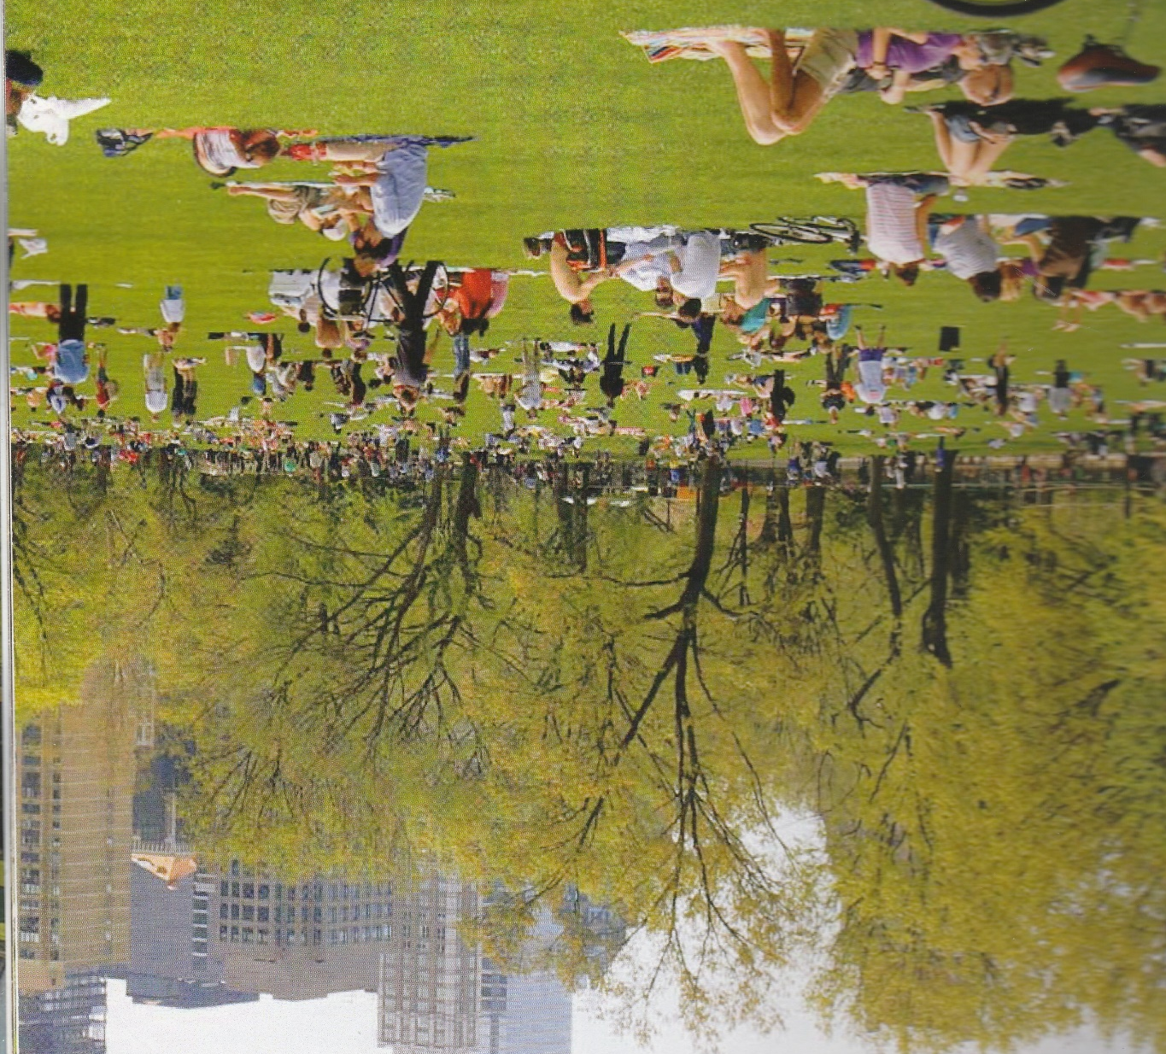
One of the worst effects of the grand prix event is that it prevents proper development of the park. This picture, envisaging a large grassed area for picnics and gatherings, was published in Parks Victoria’s ‘Albert Park Draft Master Plan’ (Nov. 2017). Such an extensive and attractive area (eg., on the lake edge, with easy access from Albert Road) could not be created in Albert Park while it continues to host the grand prix. (The actual area might be in Central Park, New York.)
The Draft Master Plan was circulated for comment after which a final master plan was developed ‘to set a 25-year vision for Albert Park
- to guide it through the next stage of its history
- to maximise its contribution to the health and wellbeing of the Victorian community
- provide a series of interventions to improve the quality of experiences available to visitors, in large part by improving the park environment through increased planting and improving access to the park.’
Five of these 25 years have passed since these visions were created, and two new sports pavilions have been erected on Ovals 1 and 2, but there is little or no outcome in terms of increased planting or improved access designed to maximise the health and well-being of ordinary visitors. What we have actually seen is a $20 million project to increase the quality of experience for motor racing fans, ie, the widening of corners and re-surfacing the grand prix circuit which will increase speeds beyond 300 kph and decrease lap times by a few seconds.

The right place for motor sport
There are many amateur motor sports clubs in AustraIia which stage events such as rallies on public roads which are noisy and dangerous and it could be argued that that such events should be banned. A better solution would be to provide proper facilities for these clubs. The Mount Panorama circuit at Bathurst, NSW, built in the 1930’s, is a good example.
Another, outstanding example is the Circuit of the Americas, built in 2012 in 1500 acres of open countryside outside Austin, Texas, USA (see aerial photo below). This circuit has been designed to provide year-round use for a wide range of activities in addition to F1, NASCAR, Indycar and MotoGP and go kart racing, such as music concerts and mass meetings and entertainments. There is an amusement park, a camping area and ample car parks.
Over the past 28 years SAP has maintained that the right place for the Melbourne F1 grand prix is in a permanent circuit, and one proposed location has been next to the Avalon airport where operation could be year-round. There would be no need to try and emulate the scale of Texas circuit, rather that of the Mt Panorama circuit. Undulations could be provided to make the racing more interesting than in the flat Albert Park track. Unsealed dirt tracks could be part of the plan to cater for motor bike events and off-road driver training. As for the cost ($250-300 million?) this would be partially offset by eliminating the annual bill for the Albert Park temporary circuit (now around $35 million). There is also the option of involving motor sport and related industry groups in joint ownership and operation.
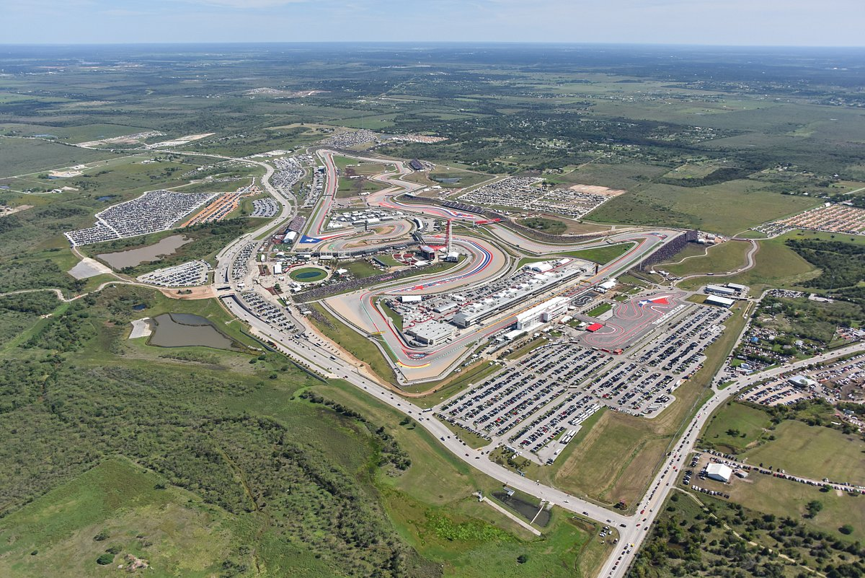
The ‘Circuit of the Americas’ built outside Austin, Texas, where the 2022 US Grand Prix was held on October 23. It operates continuously, catering for events ranging from motor sport to music concerts.
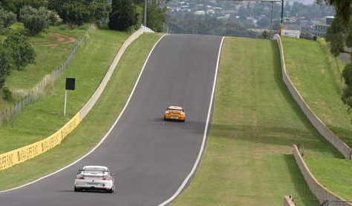
The Mount Panorama circuit, Bathurst, NSW, has operated since the 1930’s as a tourist road and as a car racing circuit. Undulations make the racing more entertaining.
The wrong decision
The previous article discussed the ‘right place for motor sport’, in particular the right place for an F1 grand prix. There is of course an entirely valid point of view that F1 racing should not be staged at all because of its contribution to climate change. It is also just an entertainment which acts as a marketing platform for the automotive industry and supporters and makes a negative contribution to the health and wellbeing of its patrons.
The US-owned F1 business is well aware of climate change and is attempting to reduce emissions from the cars by the use of hybrid engines and biofuels. However, during the racing season and in testing, the cars contribute only 0.7% of total emissions, while 45% is generated by the road, sea and air transport around the world of teams, cars, gear, and F1 Paddock Club equipment. It does not really matter how efficient the cars are made, F1 will continue to make a major environmental impact.
F1 racing in Melbourne generates about 13,000 tonnes of carbon emissions and substantially more comes from other events on the 4-day program, plus the emissions arising from the building and dismantling of the temporary circuit. Despite these facts, and with huge operating losses, serious disruption to sports clubs and the public’s use of the park, and in the absence of any real economic justification, the Victorian government has contracted to stage a further 13 years of these events in Albert Park. The unequivocal evidence that the Earth is warming at an unprecedented rate and that human activity is the principal cause has been ignored. This has apparently been done to win political support from the ‘big end of town’. SAP considers this decision to be reprehensible. We note that the state opposition has not raised any objections.
Looking back …..
‘Sacrifice of the People’s Playground’
Below is an editorial (with minor edits) published in the April 2001 issue of SAP’s newsletter, written by the then convenor, Ross Ulman. As Ross said, ‘the more things change the more they stay the same.”
“The book, ‘People’s Playground: a history of the Albert Park’ by Jill Barnard and Jenny Keating, makes interesting reading. It tells us that the Albert Park Reserve was proclaimed a public park in 1864, and that the park’s history has been one of “controversy, funding crises, government neglect, commercial interests and passionate partisanship”. “The combination of grass, lake and roadways seems to spark an inevitable desire for races round the park”. Given this recipe, it is no wonder that the park has very often been the subject of public protest.”
“Motor racing in the park was first mooted in the 1930’s . However, this attracted a howl of protest which resulted in the Minister for Lands declaring “I think it would be wrong to have this race in Albert Park. More suitable sites could be found.” The more things change the more they remain the same.”
“Grand prix motor racing in the park started in 1953. Public opposition to the races grew following the 1956 grand prix, and after the 1958 race premier Bolte announced that there would be no more motor racing in the park whilst his government was in office. Public protests on Albert Park issues then became more organized, and from the 1950’s the Albert Park Protection League (APPLE) lobbied the state government and the media.”
“The final page of ‘People’s Playground’ proclaimed: “Albert Park is still there, still surviving, still inspiring incredible loyalty and passion among it’s devoted supporters”. Indeed. Never since its 1864 proclamation has the park been sacrificed to commercial interests as it is at present, with the connivance of a government which astoundingly, has resorted to secrecy to protect those interests’.
“And at no time since, has the park had a more committed and organized community advocate and defender than Save Albert Park. The facts are on our side. We will continue our campaign for as long as it takes.”
2023 grand prix
Next year’s Melbourne grand prix will be held on April 2, the third race of the season, after Bahrain and Saudi Arabia. There will be a ‘record’ 24 races during the season, including a night race through Las Vegas.
Melbourne’s race appears to have permanently lost its treasured position as the season opener, and being
one in 24 races (compared with being one in 20 races in 2019) will have lost some of its significance.

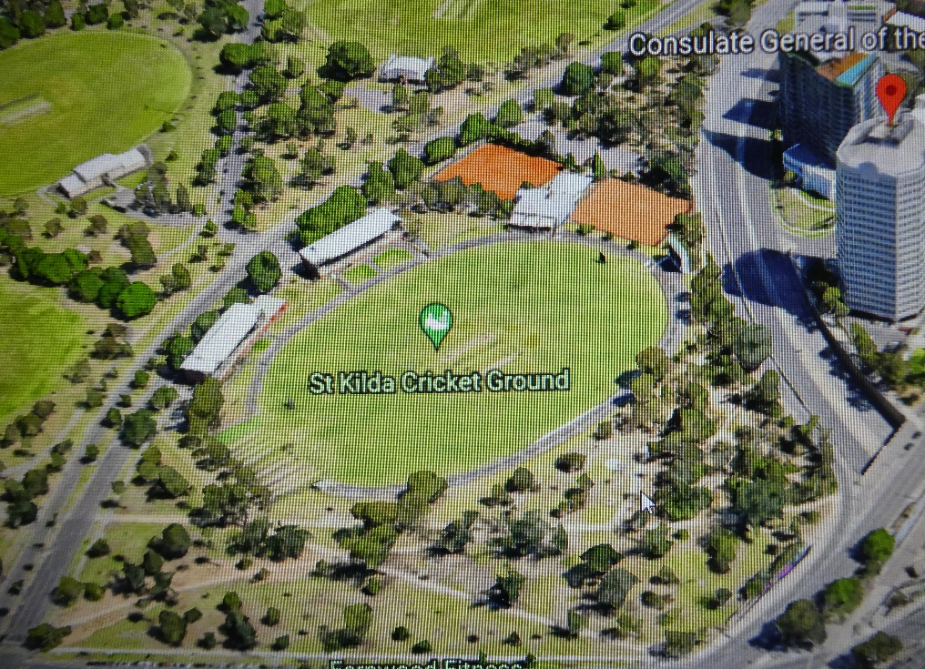
SAP Park Volunteer Group
Since 2006, SAP has operated a volunteer group which works in the park on a regular weekly basis. Starting with spreading mulch under the elm trees bordering Albert Road, and with the cooperation of the park rangers, the group extended its activities to the construction of tree guards, the repair of park seats and
then to the design, building and installation of the ‘elm slab’ seats around the lake.
In recent years the group has focussed on the Ngargee (Corroboree Tree) area at St Kilda Junction (lower right in the ‘Google Earth’ view.)
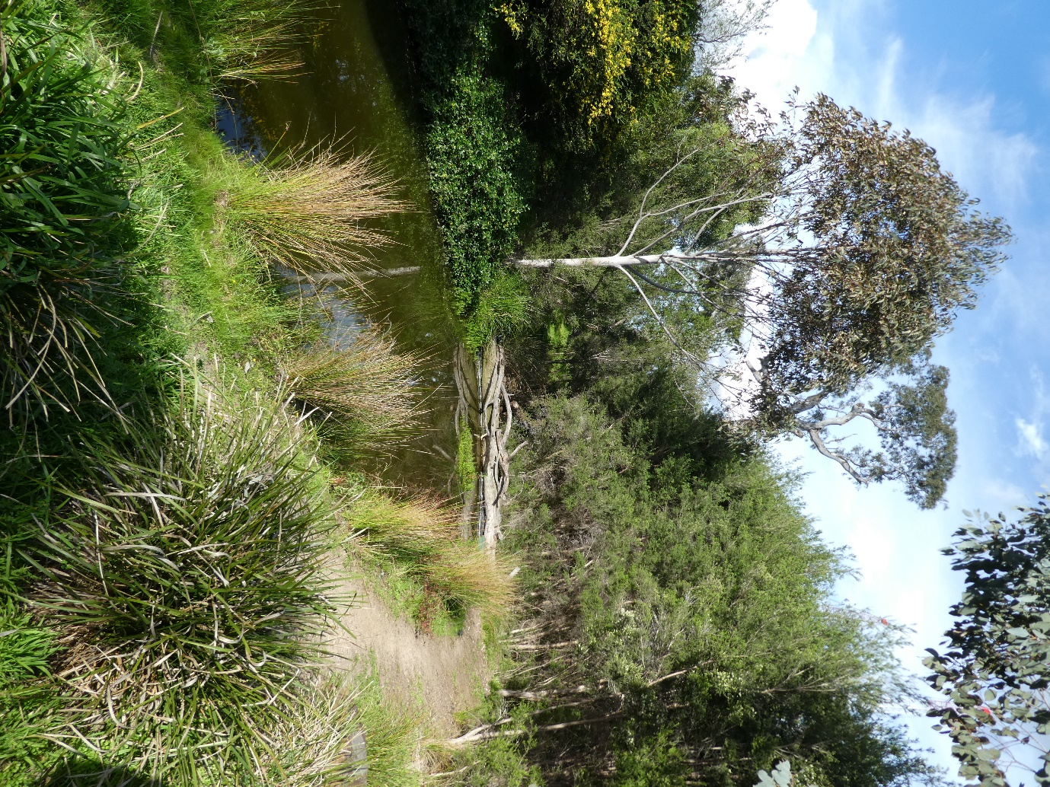
This area is also described by a 1980’s sign as the ‘Albert Park Native Bushland Restoration’. The group has also started to take an interest in the ‘Red Gum Triangle’ area (top right).
Work in the Ngargee Tree area involves general maintenance, weeding and re-planting but also some major projects. In 2018, aided by a grant from the City of Port Phillip, the ‘Reflection Pool’ was reinstated and the surrounding banks were planted. The lower photo, taken in early October, shows the Ngargee Tree partially obscured by a young mahogany gum. Parks Victoria has agreed to the removal of this tree ‘in the interests of the purpose of the Reflection Pool and the integrity of the indigenous vegetation in the area’.
With another grant from the City of Port Phillip the group has enhanced the entrance to the park at St Kilda Junction.

Save Albert Park Inc. No. A0040971X
Media enquiries: Peter Logan, mob. 0412 697 074; email peterandjoanlogan@hotmail.com
Membership/accounts: Greg Byrne, tel. 9645 1301; email greg-byrne@bigpond.com
SAP Newsletter/campaign: Peter Goad 9699 7932; email pwgoad@outlook.com
Post: PO Box 1300, South Melbourne BC 3205

